CLASS DESCRIPTIONS
BARRE-LESS – A basic BARRE workout without the barre using high repetitions of small precise movements to tone muscle, build strength, teach muscle control & improve overall posture. (55 minutes)
BEGINNER YOGA - A gentle basic class with easy flow between poses. This is a good place to learn relaxation techniques, beginner poses & become comfortable with yoga. (55 minutes)
BODYATTACK – A workout that combines athletic aerobic movements with strength and stabilization exercises. (55 min)
BODYATTACK EXPRESS – A workout that combines athletic aerobic movements with strength and stabilization exercises. (30 min)
BODYCOMBAT – Martial Arts based fitness program with moves from karate, taekwondo, kung fu, kickboxing, muay thai & tai chi. (55 min)
BODYCOMBAT 45 – Martial Arts based fitness program with moves from karate, taekwondo, kung fu, kickboxing, muay thai & tai chi. (45 min)
BODYPUMP - A revolutionary weight-training workout that strengthens, tones and defines every muscle in your body. (55 min.)
BODYSTEP – A simple, athletic step workout with high intensity intervals followed by muscle conditioning tracks (55 min)
BODYBALANCE – A yoga, tai chi & Pilates workout emphasizing strength & flexibility movements. (55 min.)
CARDIO SALSA – A Latin style hi/lo dance aerobics class. Great cardio! Open to all levels. (55 min.)
CARDIO SCULPT - 20 minutes of warm-up/light cardio, followed by strength, balance, and core work. All levels. (55 min.)
CYCLE TO THE CORE – 45 minutes of cycling plus 15 minutes of core conditioning. (60 min.)
DANCE CARDIO – A high energy dance class where cardio meets fitness benefits. All levels (55 min.)
GRIT STRENGTH – A HIIT workout designed to improve strength and build lean muscle using a barbell and weights. (30 min.)
HIIT CIRCUITS – High Intensity Interval Training circuits using a variety of equipment. Open to all levels. (55 min.)
HIIT CYCLE - High Intensity Interval Training circuits on and off the bike using a variety of equipment, including bands and dumbbells. Open to all levels. (55 min.)
INTRO TO TENNIS – Tennis Fitness for anyone & everyone who wants to understand the basic rules of the game in a fun easy to learn format.
(AM -45 min. PM – 60 min.)
INTRO TO PICKLEBALL – Come learn the basics of this fun paddle sport that combines elements of tennis, badminton & ping-pong.
(AM -45 min. PM – 60 min)
LES MILLS CORE – A complete workout that uses training principles to build strength, stability and endurance in the muscles that support your core. (45 min.)
MEDITATION - Meditation can help us to eliminate negative thoughts, worries, anxiety; all factors that can prevent us from feeling happy. It has been proven that the practice of meditation, carried out on a regular basis, will mitigate the symptoms of stress and anxiety. The goal of meditation is to go beyond the mind and experience our essential nature - which is described as peace, happiness and bliss. But as anyone who has tried to meditate knows, the mind itself is the biggest obstacle standing between ourselves and this awareness. (25 min.)
PILATES SCULPT – A combination of a Mat Pilates class with additional toning and sculpting. (55 min.)
POSTURE & BALANCE – Flexibility and core strength is the focus. Learn movements that will help improve posture. (25 min.)
RESTORATIVE YOGA - A combination of gentle Hatha and restorative work. Improves range of motion & joint mobility reducing the effects of stress. (55 min.)
RESTORATIVE YOGA / MEDITATION - A unique combination of Restorative Yoga plus Meditation. (55 min.)
ROAD RIDE – Taking stationary cycling to a whole new dimension by adding great music, a motivational instructor and a group exercise setting. All levels. Bring a friend and have fun! (45 min.)
RPM – An indoor cycling class based on outdoor riding. Ride to inspirational music over the equivalent of 20-25 kilometers of varied terrain, controlling the intensity of your workout with a resistance dial and pedal speed. (50 min.)
SCULPT & STRETCH - The perfect workout – 20 minutes of warm-up/light cardio, 20 minutes of strength and 15 minutes of cool-down/stretch. All levels. (55 min.)
SH’BAM - A simple but seriously hot dance class set to a soundtrack of chart topping popular hits. (55 min)
SPRINT – A HIIT class utilizing a bike for speed /power and endurance training. (30 min.)
SWEAT SHOP - A super fun, high energy, crazy, dynamic, insanely effective workout in a group environment that combines many different elements of fitness into one amazing class! (55 min.)
TAI CHI 25 – Slow graceful movements & synchronized deep breathing. Works on posture, core strength & flexibility. Helps eliminate negative thoughts, worries, stress and anxiety. The goal is to go beyond the mind and experience peace, happiness and bliss. (25 min.)
TAI CHI – Slow graceful movements & synchronized deep breathing. Works on posture, core strength & flexibility. Helps eliminate negative thoughts, worries, stress and anxiety. The goal is to go beyond the mind and experience peace, happiness and bliss. (55 min.)
VINYASA YOGA – A style of yoga that connects a series of poses together so that you move from one to the other, seamlessly, using breath. (55 min.)
WATER-AEROBICS – An aerobic, total body workout performed in chest deep water. (55 min.)
DEEP WATER CONDITIONING – A deep water class open to all levels. Great cardio with no hard impact! Meet in the lap pool. (55 min.)
YOGA – A practice of adopting awareness, utilizing deep, rhythmic breathing and controlled postures. (55 min.)
ZUMBA – A calorie burning dance fitness party with a mix of low & high intensity interval style moves. Open to all levels! (55 min.)
ZUMBA TONING - An awesome combination of great music, cardio and toning with hand weights! (55 min.)

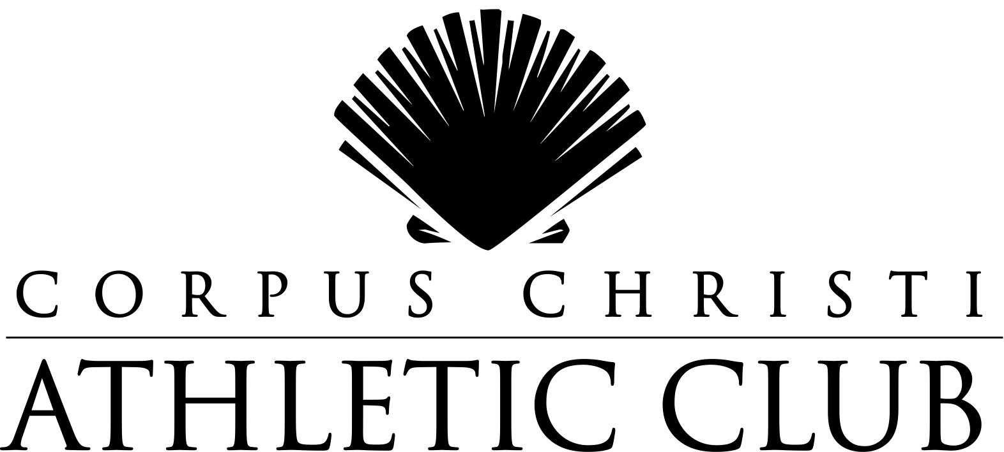

Group Exercise Schedule
Current as of: October 1, 2023

Airline at Holly Road
Corpus Christi, TX 78468-8150
361-992-7100
www.ccathleticclub.com
The Corpus Christi Athletic Club Group Exercise Program offers a wide variety of classes for members of all fitness levels, from beginner to advanced. Our instructors are the finest in the Corpus Christi area, with the knowledge and experience to provide a safe and fun atmosphere in each class. Our Asst. GM, Monica Delgado welcomes your input and may be contacted at 361-992-7100 ext.1148 or mdelgado@ccathleticclub.com. Group Exercise Classes are free with membership.
Club Hours
Monday - Thursday 5:00am to 10:00pm
Friday 5:00am to 9:00pm

Saturday & Sunday 8:00am-7:00pm

Schedule Subject to Change

B.A.S.E. Training Room
Time | Monday | Tuesday | Wednesday | Thursday | Friday | Saturday | Sunday
6:00 p.m. |  |  | Sweat Shop  Lucas & Staff

TENNIS COURT
Time | Monday | Tuesday | Wednesday | Thursday | Friday | Saturday | Sunday
9:00 a.m. |  |  |  |  | Intro To Pickleball  Joseph
9:45 a.m. |  |  |  |  | Intro To Tennis  Michael
6:30 p.m. |  |  |  | Intro To Pickleball  Joseph
7:15 p.m. |  | Intro To Tennis  Michael

LAP POOL – DEEP WATER CONDITIONING
Time | Monday | Tuesday | Wednesday | Thursday | Friday | Saturday | Sunday
6:00 p.m. |  | Lisa L.

REC POOL – WATER AEROBICS
Time | Monday | Tuesday | Wednesday | Thursday | Friday | Saturday | Sunday
9:00 a.m. | Josie | Lisa L. | Katie | Lisa L. | Katie
1:00 p.m. | Lisa L. | Lisa L. | Donna | Lisa L.
6:00 p.m. | Lisa L. |  | Lisa L.

